Lab – Observing DNS Name Resolution

1. Objectives

* Observe the conversion of a URL to an IP address.
* Observe DNS lookup using the nslookup command.

1. Background / Scenario

Domain Name System (DNS) is invoked when you type a Uniform Resource Locator (URL), such as [http://www.cisco.com,](http://www.cisco.com/) into a web browser. The first part of the URL describes which protocol is being used. Common protocols are HTTP (Hypertext Transfer Protocol), HTTPS (Hypertext Transfer Protocol over Secure Socket Layer), and FTP (File Transfer Protocol).

DNS uses the second part of the URL, which in this example is [www.cisco.com.](http://www.cisco.com/) DNS translates the domain name (like www.cisco.com) to an IP address to allow the source host to reach the destination host.

Work in pairs to complete this lab.

1. Required Resources

* 1 PC (Windows 10) with Internet connectivity
  + 1. Observe DNS conversion.
       1. Right-click **Start** and select **Command Prompt**.
       2. At the command prompt, type **ping cisco.com** and pressenter. The computer needs to translate cisco.com into an IP address so it knows where to send the Internet Control Message Protocol (ICMP) packets. Ping is a type of ICMP packet.
       3. The first line of the output shows cisco.com converted to an IP address by DNS. You should be able to see the effect of DNS even if your school has a firewall that prevents pinging, or if Cisco has prevented people from pinging their web server.

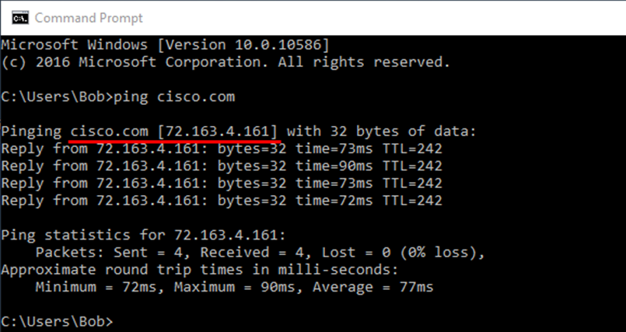

Which IP address is shown on the screen?

Is it the same as the one shown in the figure?

Should cisco.com always resolve to the same IP address? Explain.

____________________________________________________________________________________

* + - 1. Work together with another student and discuss one or two other application (besides the **ping** command) in which the computer would need to use DNS to translate a domain name to an IP address.

____________________________________________________________________________________

* + 1. Verify DNS operation using the nslookup command.
       1. At the command prompt, type the **nslookup** command and press enter.

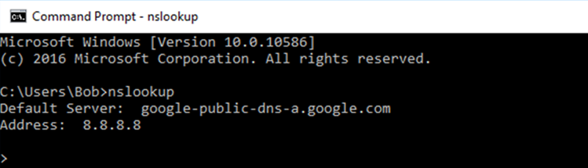

The image above shows that the Default DNS Server was configured to use a Google DNS server. What is your Default Server listed as? __________________________________________________________

* + - 1. After issuing the previous **nslookup** command, notice how the command prompt changed to a single **>**. This is the **nslookup** program’s prompt. From this prompt, you can enter commands related to DNS.

At the prompt, type **?** to see a list of all the available commands that you can use in **nslookup** mode.

List three commands that you can use with **nslookup**:

____________________________________________________________________________________

____________________________________________________________________________________

____________________________________________________________________________________

* + - 1. At the **nslookup** prompt, type **cisco.com**.

What is the translated IP address?

Is the IP address an IPv4 address or an IPv6 address?

Is it the same as the IP address shown with the ping command?

At the prompt, type the IP address of the Cisco web server that you just found. What is the Name result?

____________________________________________________________________________________

* + 1. Identify mail servers using the nslookup command
       1. To identify mail servers using **nslookup**, type **set type=mx**..
       2. At the prompt, enter **cisco.com**.

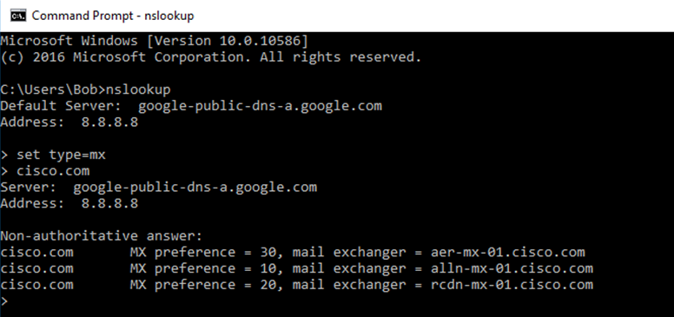

What are the names of the Cisco mail servers identified in the **mail exchanger** field?

____________________________________________________________________________________

____________________________________________________________________________________

____________________________________________________________________________________

* + - 1. At the prompt, type **exit** to return to the regular command prompt.
      2. At the prompt, type **ipconfig /all**.
      3. Write the IP addresses of all the DNS servers that your school computer uses.

____________________________________________________________________________________

* + - 1. Type **exit** and press enterto close the command prompt window.

1. Reflection
   1. If your school did not have a DNS server, what effect would this have on your use of the Internet?

_______________________________________________________________________________________

_______________________________________________________________________________________

_______________________________________________________________________________________

* 1. Some companies do not dedicate a single server for DNS. Instead, the DNS server provides other functions as well. Which functions do you think might be included on a DNS server? Use the **ipconfig /all** command to help you with this.

_______________________________________________________________________________________

_______________________________________________________________________________________

_______________________________________________________________________________________